**Create an Azure Linux virtual machine using Azure Portal**

1. From the **home** screen, click on “Create a Resource”. In the “Create a resource” screen, either search or click on **Virtual Machine -> Create**
2. Go to your resource group in which the server was created. Select **Add**.
3. Select **Ubuntu Server 18.04 LTS**.
4. In the **Basics** tab, under **Project details**, choose the default subscription (*starting with ep-labs-\*\*\*\*\**) and then choose to **Create new** resource group.

Type *myResourceGroup* for the name.

[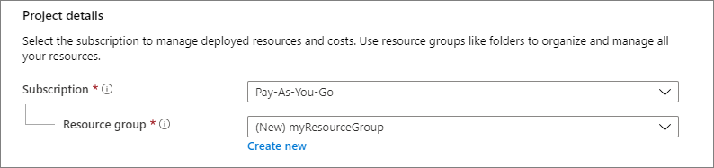](https://learn.microsoft.com/en-us/azure/virtual-machines/linux/media/quick-create-portal/project-details.png#lightbox)

1. Under **Instance details**, type *myVM* for the **Virtual machine name**, and choosefollowing details.

[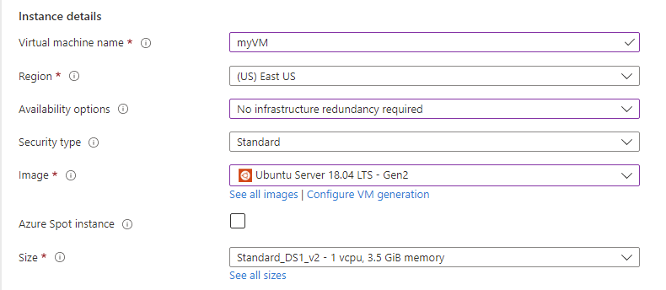](https://learn.microsoft.com/en-us/azure/virtual-machines/linux/media/quick-create-portal/instance-details.png#lightbox)

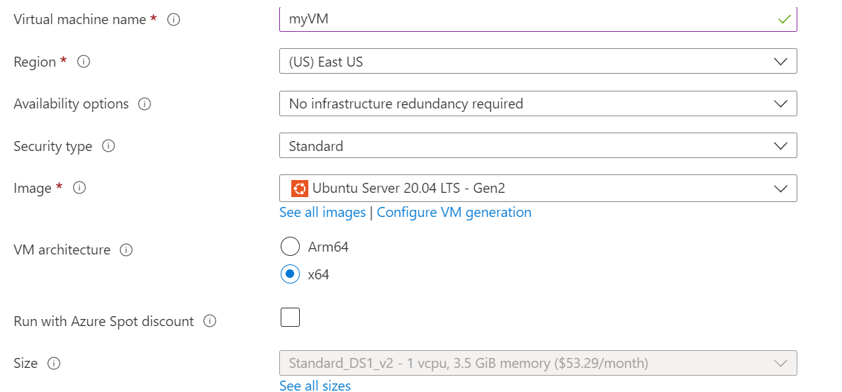

1. Under **Administrator account**, select **SSH public key**.
2. In **Username** type *azureuser*.
3. For **SSH public key source**, leave the default of **Generate new key pair**, and then type *myKey* for the **Key pair name**.

[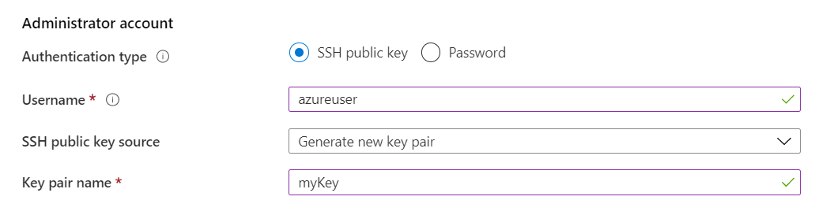](https://learn.microsoft.com/en-us/azure/virtual-machines/linux/media/quick-create-portal/administrator-account.png#lightbox)

1. Under **Inbound port rules** > **Public inbound ports**, choose **Allow selected ports** and then select **SSH (22)** and **HTTP (80)** from the drop-down.

[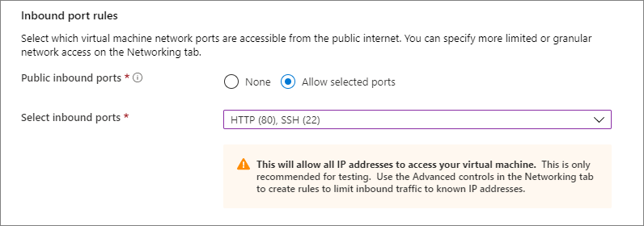](https://learn.microsoft.com/en-us/azure/virtual-machines/linux/media/quick-create-portal/inbound-port-rules.png#lightbox)

1. Select **Review + Create**.
2. Select **Create**. When the **Generate new key pair** window opens, select **Download private key and create resource**. Your key file will be downloaded as **myKey.pem**.

**Important**

Make sure you know where the .pem file was downloaded. You will need the path to it in the next step.

1. When the deployment is finished, select **Go to resource** to view the virtual machine **Overview** page.
2. Select the public IP address and copy it to your clipboard.

[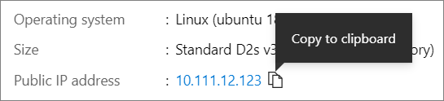](https://learn.microsoft.com/en-us/azure/virtual-machines/linux/media/quick-create-portal/ip-address.png#lightbox)

**OPTIONAL – CONNECTING TO THE VIRTUAL MACHINE**

1. Open Cloud shell -> bash -> use the defaults (to create storage )
2. Run the following commands from command prompt

mkdir Downloads

Upload the *.pem file

mv myVM_key.pem Downloads

chmod 600 myVM_key.pem

ssh -i myVM_key.pem azureuser@20.127.111.15